Importing Files

With Google Docs

- In the main Google Docs window, click on the Upload button at the top left corner of the screen.

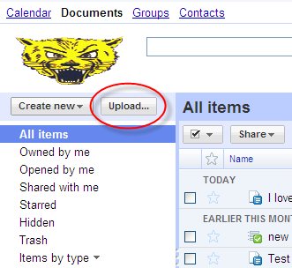

- Click Select files to upload.

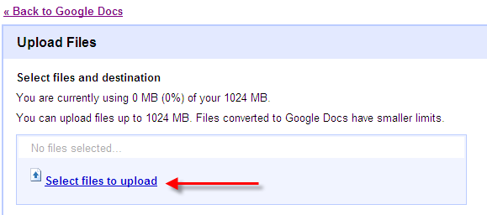

- Click to highlight the document for uploading. Then click the Open button.

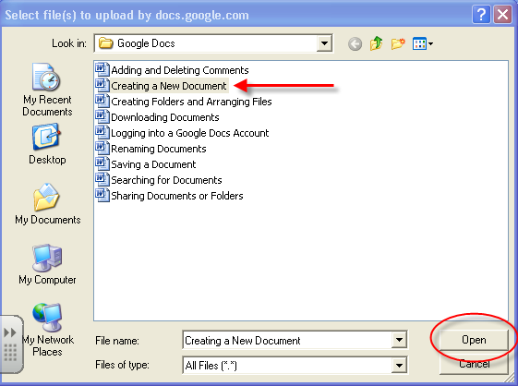

- The Covert documents, presentations, and spreadsheets to the corresponding Google Docs formats check box are checked by default. Leave the box checked.

Click on Destination folder to select a folder for the file to be uploaded to. Select any folder inside of the User’s Google Docs account.

Click Start upload.

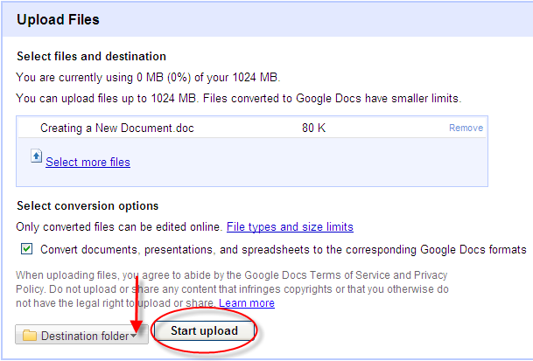
- Once the document has finished uploading, the user can choose to click Upload more files to add additional files or click Back to Google Docs to view the document.

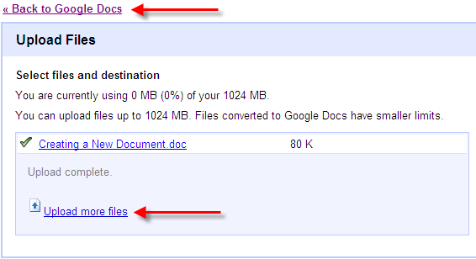

The newly uploaded document is now available in the Docs list view.

